Anita Roddick 1942-2007
Anita Roddick worked for the United Nations before opening her first Body Shop in 1976 in Brighton, UK. Her idea was to provide skin care products in refillable containers as well as tiny samples. In addition, she committed the company to marketing its products with truth rather than hype.
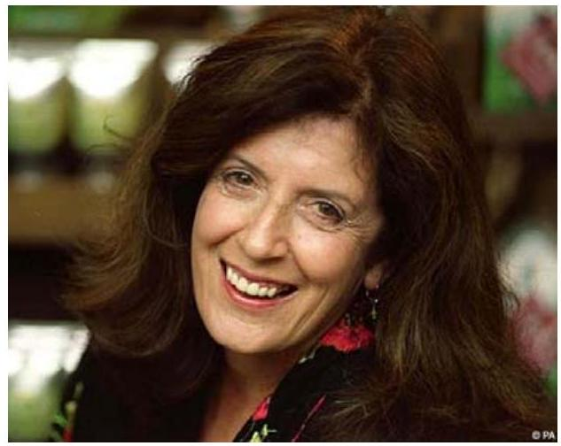
By 1991, the Body Shop had expanded internationally and had over 700 stores. By the early 2000s, studies showed that the company had one of the most trusted brands in the UK.
From Wikipedia:
Roddick was known for her campaigning work on environmental issues and was a member of the Demos think tank's advisory council. Children On The Edge (COTE) is an organisation that Roddick founded in 1990, in response to her visits to Romanian orphanages. Upon seeing the conditions the children were in, she created COTE to help manage the crisis and worked to de-institutionalise the children over the course of their early life. COTE's mission focuses on disadvantaged children affected by conflicts, natural disasters, disabilities, and HIV/AIDS. On 13 December 2005, the National Post reported that Roddick had decided to turn her back on the world of commerce and give away her fortune, worth some $£51$ million ( $\$104$ million).
On 14 February 2007, Roddick revealed she had been diagnosed with hepatitis C. Roddick said, "I have hepatitis C. It's a bit of a bummer, but you groan and move on". On live television, Roddick explained that she had a large blood transfusion in 1971, after the birth of her younger daughter, and that she was convinced that the transfusion had infected her with hepatitis C . She died seven months later.
Richard Rumelt 2011:
The strategic brilliance of the Body Shop was that the huge well-financed cosmetics firms couldn't respond. They had spent decades and billions to convince women that stuff in bottles and tubes could make them look young and beautiful. Anita Roddick made a very different claim-that cosmetics were fun and enjoyable. They felt good and smelled good. Furthermore, she stressed the environmental friendliness of her packaging and its contents. It was marvelous judo.
She also saw the importance of creating her own retail outlets. Even if she were successful at putting her products next to competitors' in shops and department stores, the whole atmosphere and the habits and attitudes of the sales personnel would put her at a disadvantage.

